MODULE 8

Activity submission

Learning outcome:
LO1: Complete part of an entity relationship diagram.
LO2: Complete part of a data flow diagram.
LO3: Practise formulating data definitions.
LO6: Investigate how to compile specifications that improve user experience.

1. Instructions and guidelines (Read carefully)

Instructions
1. Insert your name in the file name. Save the file as: First name Surname Activity Submission 8 – e.g. Lilly Smith Activity Submission 8. NB: Please ensure that you use the name that appears in your student profile on the Online Campus.
2 Write all your answers in this document. At the “Start writing here” prompt, please type your answer on the line immediately below this prompt and ensure you do not exceed the answer length limit. Do not adjust answer table dimensions or font formats. If your answer does not fit into the table, then your answer is too long. Diagrams that are illegible, distorted, too small to view at an A4-equivalent zoom or are not entirely contained within the allocated answer space risk not being assessed.
3 Submit your assignment in Microsoft Word only.
4 Do not delete the plagiarism declaration or the assignment instructions and guidelines. They must remain in your assignment when you submit.
PLEASE NOTE: Plagiarism cases will be penalised according to the Head Tutor’s and GetSmarter's discretion.
IMPORTANT NOTICE: Please ensure that you have checked your course calendar for the due date for this assignment. This calendar is available on the Online Campus.

Guidelines:
- This activity submission is based on the activity submission scenario for Module 8. You can download the activity submission scenario document from the Online Campus.
- There are initially ten pages and three questions in this assignment.
- Each question in this assignment relates to its corresponding unit of the module. Complete each question as you work through each unit.
- Make sure that you have carefully read and fully understood the questions before answering them. Answer the questions fully but concisely and as directly as possible. Follow all specific instructions for individual questions (e. g. “list”, “in point form”).
- Answer all questions in your own words. Do not copy any text from the notes, readings or other sources. The assignment must be your own work only.
Plagiarism declaration:
1. I know that plagiarism is wrong. Plagiarism is to use another’s work and pretend that it is one’s own.
2. This assignment is my own work.
3. I have not allowed, and will not allow, anyone to copy my work with the intention of passing it off as his or her own work.
4. I acknowledge that copying someone else’s assignment (or part of it) is wrong, and declare that my assignments are my own work.

2. Mark allocation
Each part of the question receives a mark allocation. However, you will only receive a final percentage mark and will not be given individual marks for each question. The mark allocation is there to show you the weighting and length of each question. Please note that line limits for each question do not indicate mark allocation. You are required to stick to the line limits. Answer all questions clearly and succinctly.
Question 1: (Unit 1) Data modelling 100
Question 2: (Unit 2) Data definitions 20
Question 3: (Unit 3) UX narrative 80
TOTAL: 200 marks

3. Assignment questions
How to create your diagrams and insert them into this document:
Draw.io is recommended and technical support is offered if you use this software. If you draw your diagram by hand and photograph it (instead of scanning it) ensure the lighting is good so that colours contrast well and text is legible.
Once you have created your diagram, either save it as a JPEG and insert it into the appropriate answer box, or take a screenshot and paste it into the answer box. To insert the file, put the cursor in the answer box, then insert the JPEG file containing your diagram. Crop out the irrelevant edges in order to maximise your diagram’s use of the answer space.

Question 1

1.1 Entity relationship diagram (ERD)

Instructions
Create an entity relationship diagram for Kabeljou based on the scenario document for Module 8 and insert your diagram in the table on the next page. (Reminder: minimum text size in your diagram is Arial size 9. Review the diagram instructions in Module 4.)

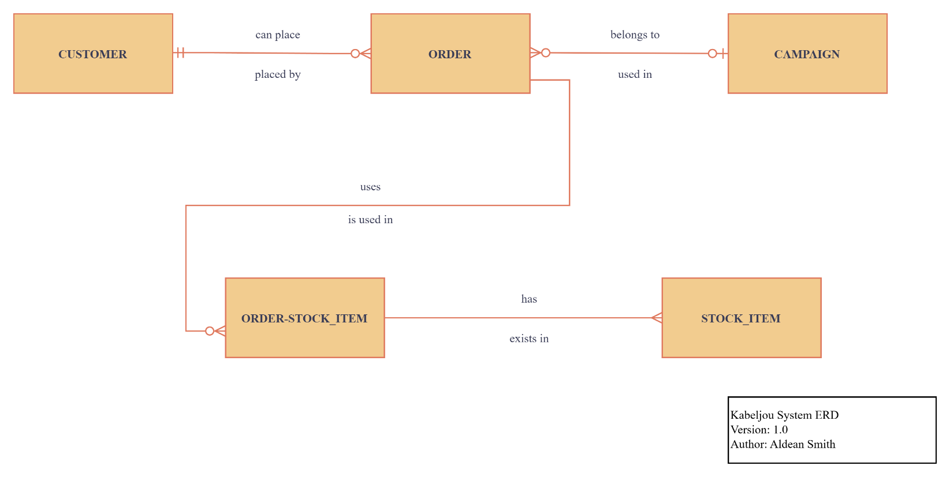

Question 1.2: Data flow diagram (DFD)

Instructions
Create a data flow diagram for Kabeljou based on the scenario document for Module 8 and insert your diagram in the table on the next page. (Reminder: minimum text size in your diagram is Arial size 9. Review the diagram instructions in Module 4.)

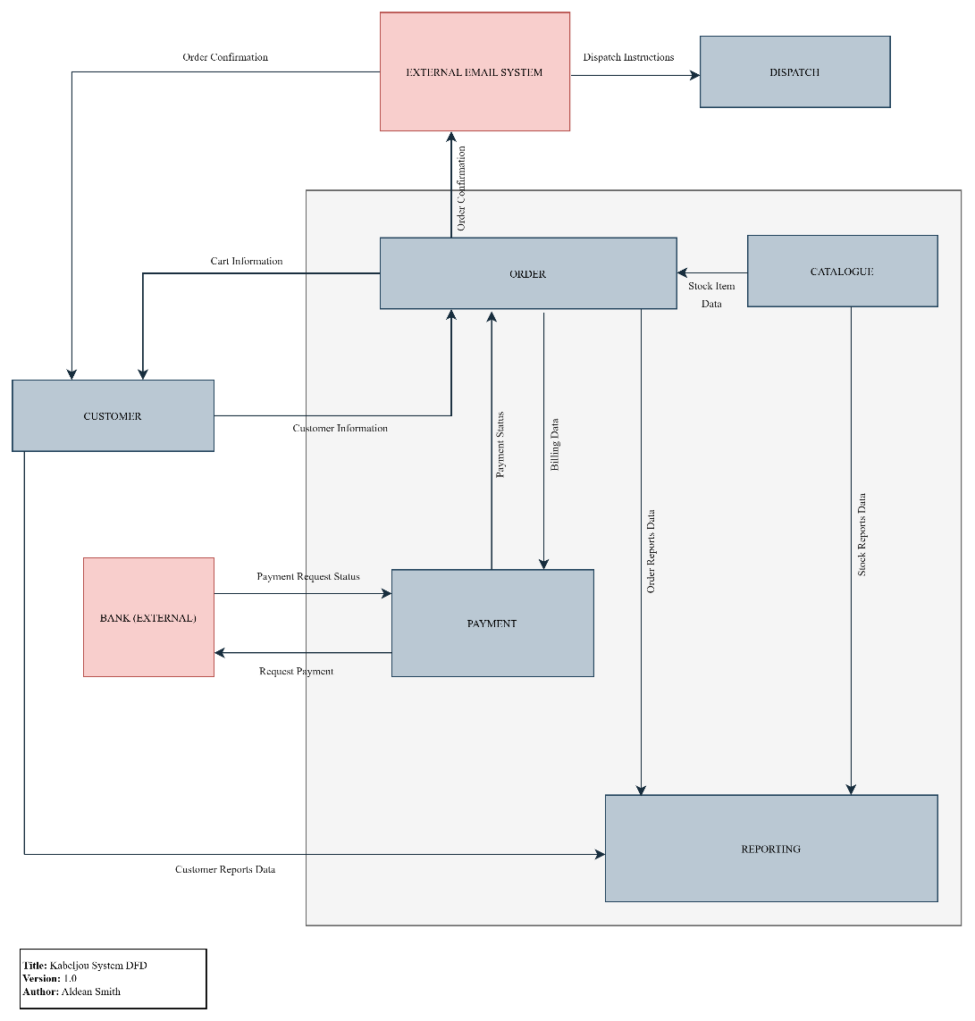

Question 2

Data definitions

Instructions
Fill in the table below to create a set of data definitions for the Customer and Order entities. For each of the given attributes you need to specify its key, type and data length (including the data range for fields that hold numbers).
Note: Type your answers in the unshaded columns only and do not adjust the tables’ dimensions or the font formatting.
Entity name: | CUSTOMER
Attribute | Key (PK / FK) | Data type | Data size
Customer ID | PK | System | 10
Create date (when the ‘Customer’ record was created) |  | Date | -
Status (e.g. Good, Blacklisted) |  | Char | 15
First name |  | Varchar | 50
Last name |  | Varchar | 50
Email |  | Varchar | 50
Cell phone |  | Varchar | 10
Date of birth |  | Date | -
Address line 1 |  | Varchar | 100
Zip code |  | Varchar | 4
Gender (e.g. Female, Unknown) |  | Char | 10

Entity name: | ORDER
Attribute | Key (PK / FK) | Data type | Data size
Order ID | PK | System | 10
Create date (when the cart record was created) |  | Date | -
Status (e.g. Paid, Abandoned, Dispatched) |  | Char | 15
Order date (when the cart was checked out and paid) |  | Date | -
Customer ID | FK | System | 10
Total pre-tax value |  | Num | 0.00 to 9999999.99
Total tax value |  | Num | 0.00 to 9999999.99
Total order value |  | Num | 0.00 to 9999999.99
Total quantity of products |  | Int | 0 to 1000

Question 3

User experience narrative

Instructions
Write a narrative specification for a customer user experience design based on the guidelines in the Module 8 scenario document. Be sure to describe the persona and include specific experiential descriptors. (Max. 25 lines. Type your answer; do not change the formatting other than to apply bold, italics, or bullets; do not insert diagrams.)
Start writing here:
Persona:
Name: Jayson
Age: 40
Occupation: Small-scale commercial fisherman
Device: Prefers to use mobile phone for browsing and buying.
User Experience Narrative:
Jayson, a busy fisherman, needs a fast and simple shopping experience. He uses the Kabeljou mobile site to log in and the home page loads quickly, with a nice friendly design. He is easily able to browse without getting lost due to product categories being clearly laid out and consistent across all pages.
When Jayson clicks on a product, he will see detailed descriptions, benefits and alternatives. Next to the main item, helpful thumbnails for related products are visible.
Jayson loves that the “Check out now” button is further out and bold on every page, allowing him to quickly buy without searching for it.
He feels safe when checking out because the site uses a one-time password (OTP) for card payments.
Upon successful payment, an immediate on-screen confirmation is shown to Jayson on the “Thank you” page. Thereafter, he receives an email with the order invoice and estimated delivery date.
Should Jayson hover over unfamiliar icons, optional pop-up help will be shown on the screen, and it can be turned off once he’s familiar with the site.
Kabeljou’s logo and branding is visible, but not overbearing to re-enforce trust.
The site looks professional and reliable because of the consistency of the colour palette and layout.
Overall, Jayson finds that the website is fast, secure, and convenient. As a result of this experience, he is a regular customer.

